This is the title of an interesting presentation
Qingzhe Zhang, Mohamed Chaker and Dongling Ma
Your laboratory, its address, its city, the country (12pt italic)

The abstract starts here, after a double vertical space. Please use only Times New Roman font 12 pts. Do not change the formatting (paper size=A4, margins=2.5cm at top, bottom, left and right sides) do not include any header or footer, do not include any page number.
Include a blank line between paragraphs. The entire abstract must fit within one single page.
If you would like to include a figure, place it inside the text followed with its caption, as illustrated in Fig. 1. Eventual references may be included at the end of the page, using this format [1].
Please, produce a high quality one-page pdf file from this document and send it by email to emp18@emt.inrs.ca, by April 15, 2018.
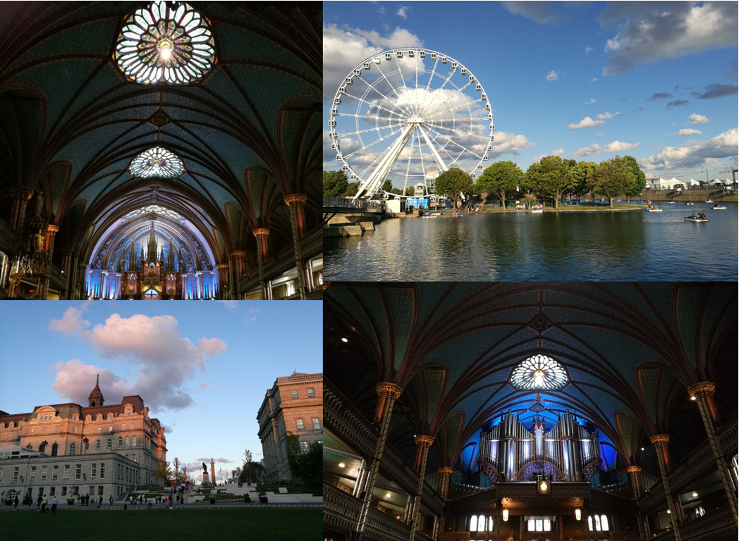
Fig. 1. Photos of beautiful and historic Montreal, the 2nd-most populous city in Canada.
[1] Q. Zhang, J. Deng, Z. Xu, M. Chaker, D. Ma, ACS Catal., 2017, 7, 6225-6234.

